Looping
______________________________________________________________________________
Q. what is loop?
Loop means if we want to perform some task repeat again and again called as loop the main goal of loop is optimize the code.

There are two types of loop?
______________________________________________________________________________
A. entry control loop: entry control loop means first check the condition and after that decide loop will be execute or not called as entry control loop.
There are two types of entry control loop
a. while loop
b. for loop.
B. exit control loop: exit control loop means first we execute the loop and after that check the condition called as exit control loop.
a. do while loop.

If we want to work with any type of loop we have three important points.
A. initialization: initialization means decide from loop will be start
B. condition: Conditions means decide how many times loop will be execute.
C. increment or decrement: gap between every iteration in forward direction as well as in backward directions.

while loop
______________________________________________________________________________
Syntax:
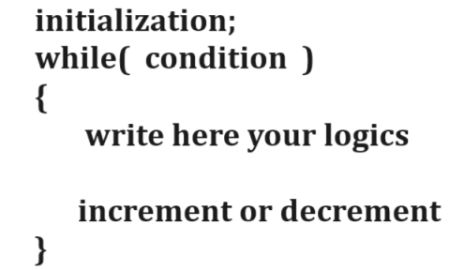
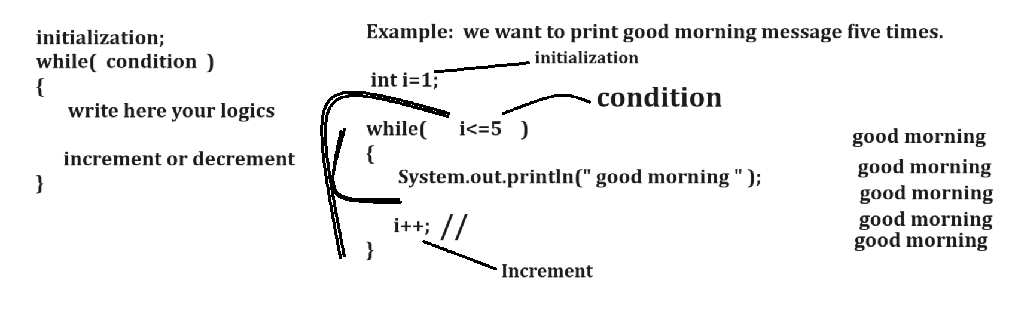
Example with source code
public class TestWhileLoop
{
public static void main(String x[])
{ int i;
i=1;//initialization
while(i<=5) //condition
{
System.out.println("good morning");
i++;
}
}
}
Example: WAP to input the number and calculate its factorial.
5 = 5 x 4 x 3 x 2 x 1 = 120
5= 1 x 2 x 3 x 4 x 5 =120
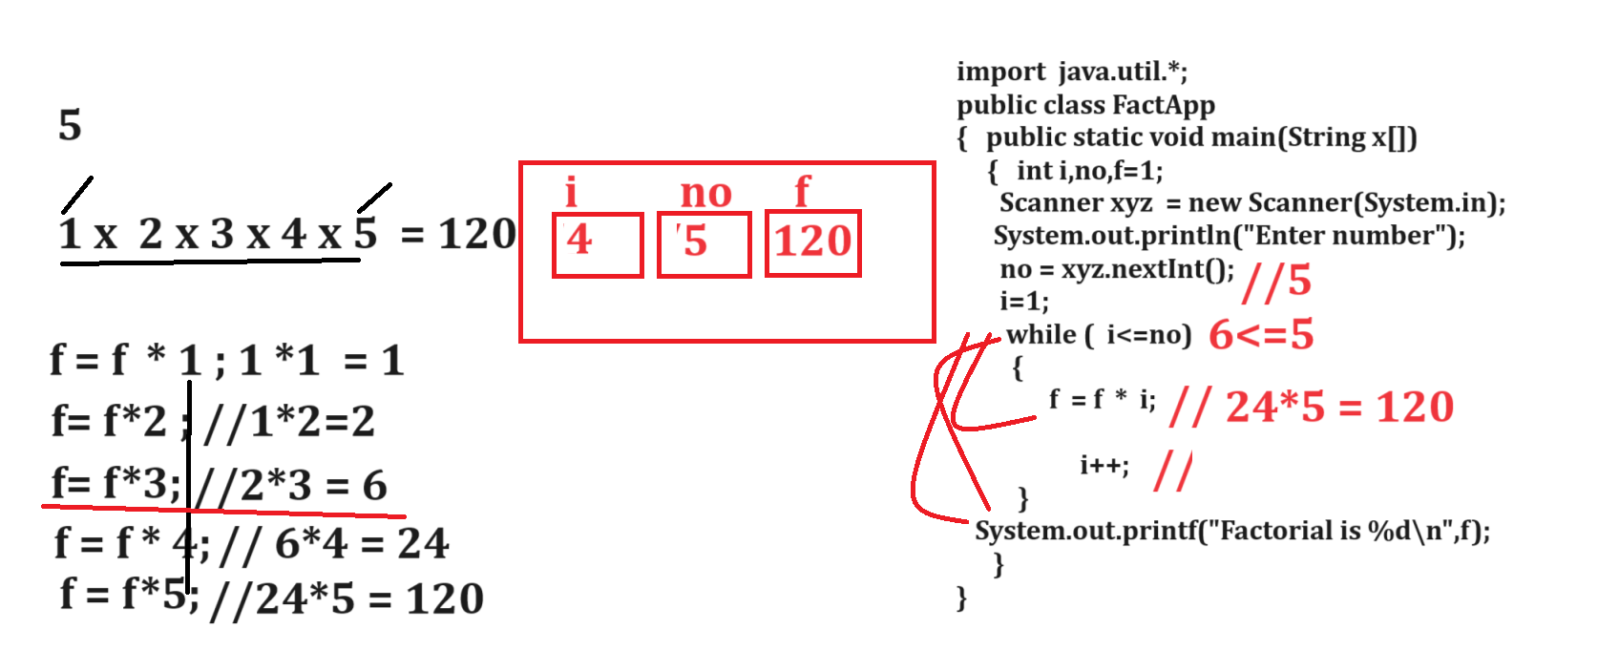

Example: WAP to calculate the sum of all natural numbers between 1 to 10?
1+2+3+4+5+6+7+8+9+10= 55

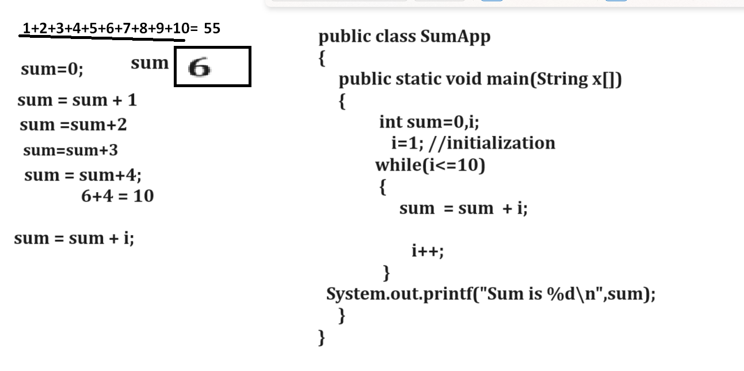
Example with source code
public class SumApp
{
public static void main(String x[])
{ int sum=0,i;
i=1;
while(i<=10)
{
sum = sum + i;
i++;
}
System.out.printf("Sum is %d\n",sum);
}
}

Example: WAP to input number and check number is perfect or not
6
1 2 3
1+2+3 = 6

8 - 1 2 4 = 1+2+4 =7 8 is not perfect
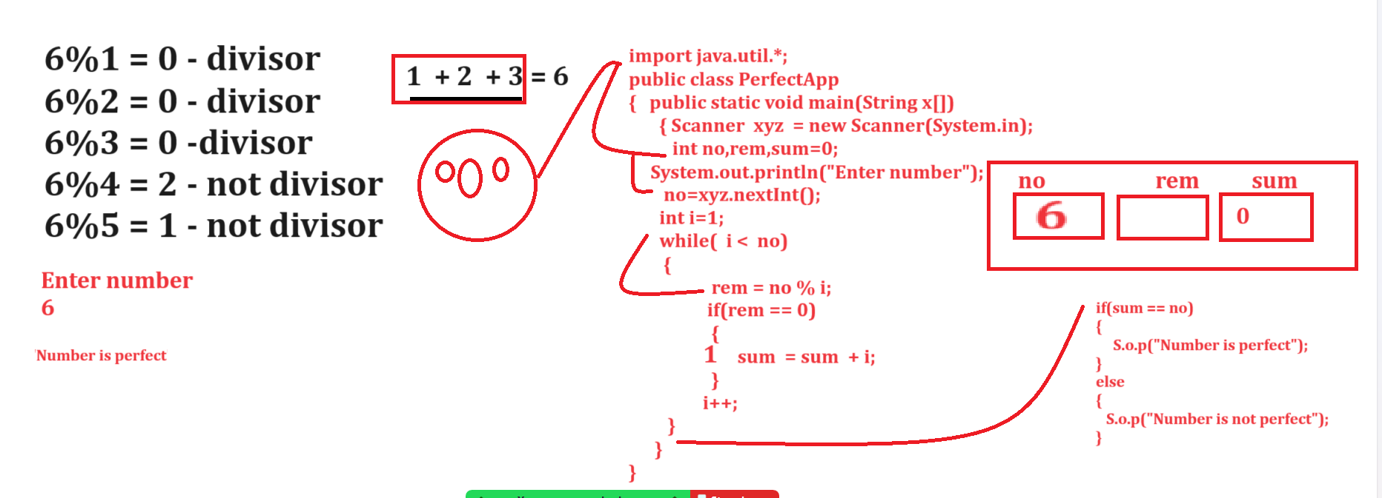

Example with source code
import java.util.*;
public class PerfectApp
{
public static void main(String x[])
{ int no,rem,sum=0;
Scanner xyz = new Scanner(System.in);
System.out.println("Enter number");
no=xyz.nextInt();
int i=1;
while(i<no)
{
rem = no % i;
if(rem == 0)
{ sum = sum + i;
}
i++;
}
if(sum==no)
{ System.out.println("Number is perfect");
}
else{
System.out.println("Number is not perfect");
}
}
}

Example: WAP to input number and reverse the number using while loop
no = 12345
Output: 54321
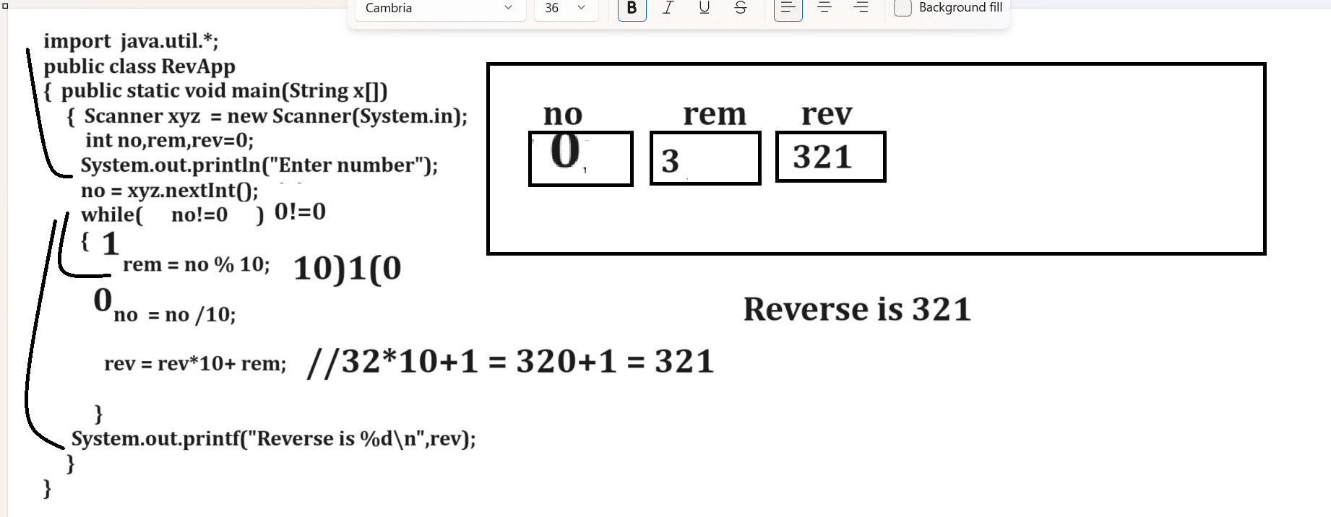

Example with source code
import java.util.*;
public class RevApp
{
public static void main(String x[])
{ Scanner xyz = new Scanner(System.in);
int no,rev=0,rem;
System.out.println("Enter number");
no=xyz.nextInt();
while(no!=0)
{
rem = no % 10;
no = no /10;
rev = rev *10+rem;
}
System.out.printf("Reverse is %d\n",rev);
}
}

Example: WAP to input number and check number is Armstrong or not
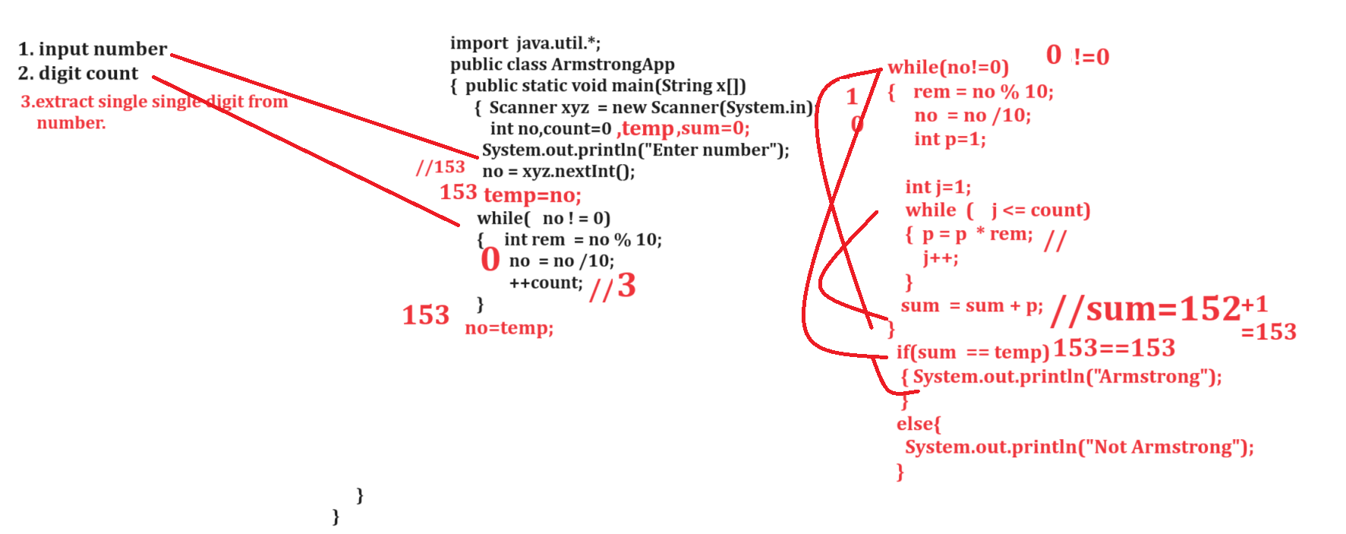
Example with source code
import java.util.*;
public class ArmstrongApp
{
public static void main(String x[])
{
Scanner xyz = new Scanner(System.in);
int temp,no,rem,rev=0,sum=0,count=0;
System.out.println("Enter number");
no=xyz.nextInt();
temp=no;
while(no!=0)
{
no = no/10;
++count;
}
no=temp;
while(no!=0)
{
rem = no % 10;
no = no/10;
int p=1;
int j=1;
while(j<=count)
{ p = p*rem;
j++;
}
sum = sum + p;
}
if(sum==temp)
{ System.out.println("Number is Armstrong");
}
else{
System.out.println("Number is not Armstrong");
}
}
}

Example: WAP to input number and check number is duck or not.
Duck number means a number which at least one zero.
Input: 1024 - it is duck number
Input: 1234: it is not duck number
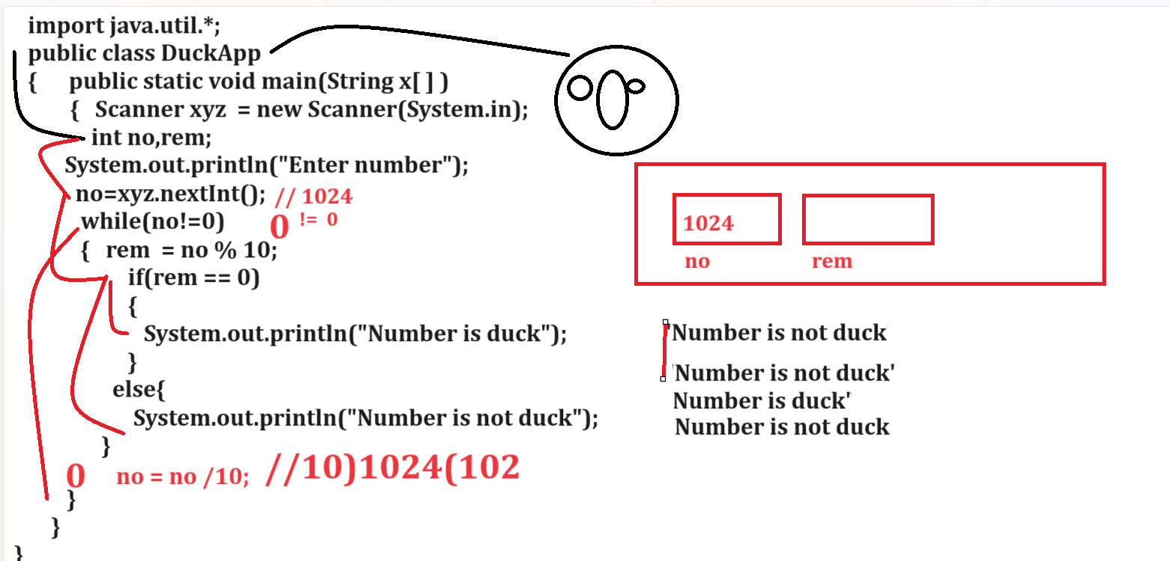
Note: if we think about above code we get output first two times Number is not duck again 3rd time number is duck and 4th time Number is not duck so this is not correct answer so we want correct output program should generate single time Number is duck or Number is not duck so if we want to solve the problem of above program we need to use flag concept in code.
Q. What is flag?
flag is term in programming which represent true or false and if we want to concept in programming, we need to declare variable and set its initial value as false or true and update the value in loop as your requirement.

Q. Why we need to use flag?
______________________________________________________________________________
normally if we use the if else block in loop and check the condition then every time we get true or false logics so there is possibility of unpredicted output or wrong output or unexpected output
so if we want to solve this problem we can declare one variable and set its initial value as false and write single if in loop and update the variable value from false to true and break the loop and after loop we can write if else block according flag variable we can check the condition so we get true or false result single time.
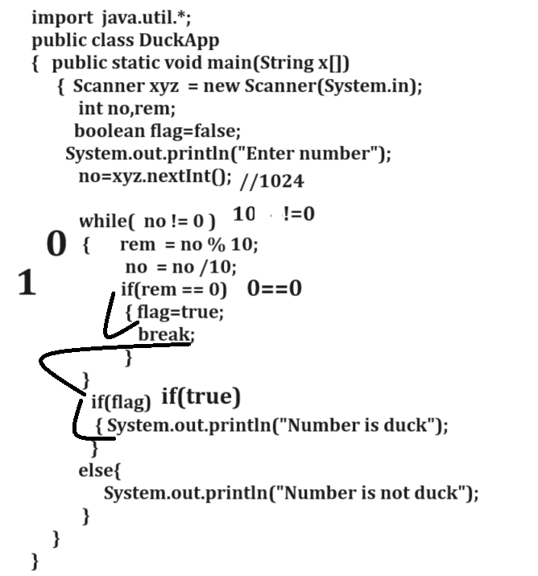

Example: WAP to input the number from keyboard and search digit present in number or not
Input: Enter number: 12345
Enter digit for search: 3
Output: digit found
Input: Enter number: 12345
Enter digit for search: 30
Output: digit not found

Example with source code
import java.util.*;
public class DigitSearchApp
{
public static void main(String x[])
{ boolean flag=false;
Scanner xyz = new Scanner(System.in);
int no,rem,sdigit;
System.out.println("enter number");
no=xyz.nextInt();
System.out.println("Enter digit for search");
sdigit=xyz.nextInt();
while(no!=0)
{
rem = no % 10;
no = no /10;
if(rem ==sdigit)
{ flag=true;
break;
}
}
if(flag)
{ System.out.println("Digit found");
}
else{
System.out.println("Digit not found");
}
}
}

Example: WAP to input number and check number is prime or not
import java.util.*;
public class PrimeApp
{ public static void main(String x[])
{ Scanner xyz = new Scanner(System.in);
int no,rem,i;
boolean flag=true;
System.out.println("Enter number");
no = xyz.nextInt(); //15
i=2;
while( i < no)
{
rem =no % i;
if(rem == 0)
{ flag=false;
break;
}
i++;
}
if(flag){
System.out.println("Number is prime");
}
else
{
System.out.println("Number is not prime");
}
}
}

Example: WAP to input the number print the Fibonacci series
5
Input:
0 1 1 2 3 5

For loop
______________________________________________________________________________
Syntax: for(initialization; condition ; increment or decrement)
{ Write here your logics
}
Example: We want to print good morning 5 times using for loop.
public class ForApp
{ public static void main(String x[])
{ int i;
for(i=1; i<=5; i++)
{ System.out.println("good morning");
}
}
}
Output
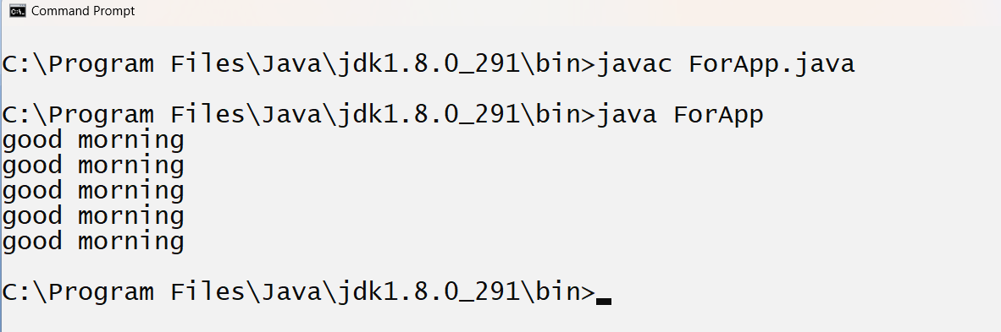
Example with for loop
public class ForApp
{ public static void main(String x[])
{ int i=1;
for(; i<=5;)
{
System.out.println("good morning");
i++;
}
}
}

Nested for loop
______________________________________________________________________________
Nested for loop means for within for called as nested for loop.
Nested for loop specially design for work with matrix

Syntax of nested for loop
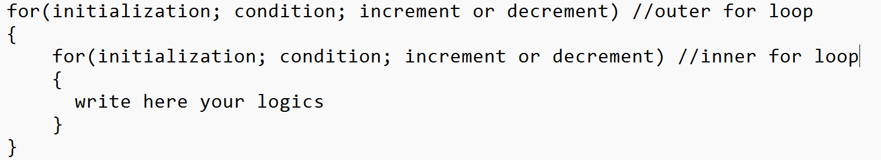

Note: if we think about above loop outer for loop work as row and inner for loop work as column.
If we think about nested for loop, then if outer loop execute only once then inner for loop execute all times

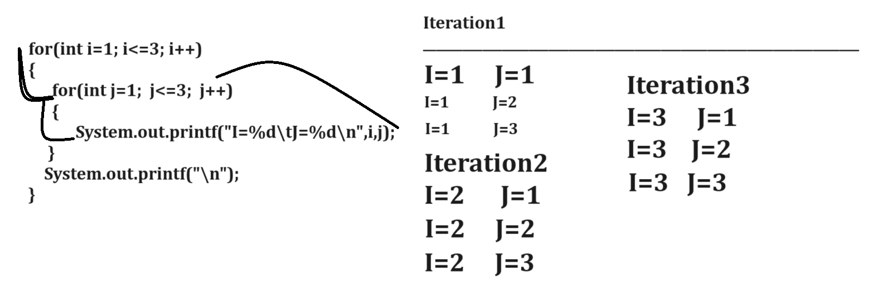

Example with source code
public class NestedForApp
{
public static void main(String x[])
{
int i,j;
for(i=1; i<=3;i++)
{System.out.printf("Iteration %d\n",i);
for(j=1; j<=3; j++)
{
System.out.printf("I=%d\tJ=%d\n",i,j);
}
System.out.printf("\n");
}
}
}
Output
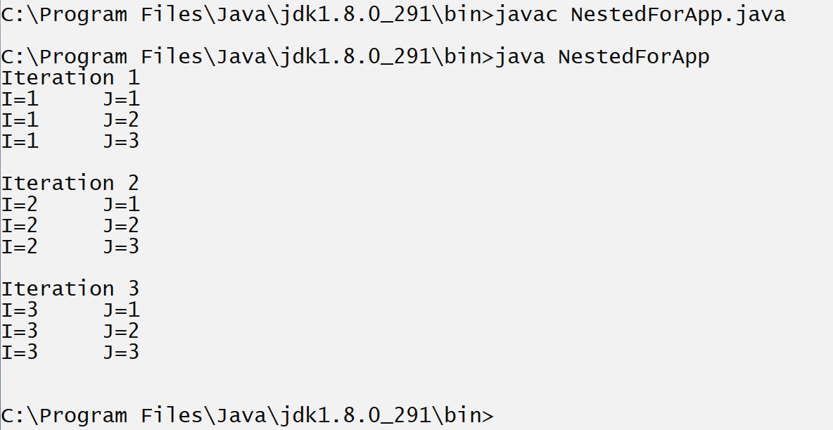
Example: WAP to print the all tables between 2 to 10.
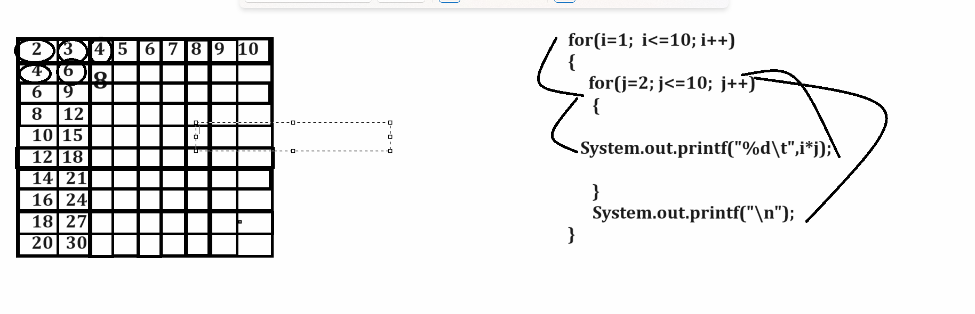
Example with source code
public class NestedForApp
{
public static void main(String x[])throws Exception
{
int i,j;
for(i=1; i<=10;i++)
{
for(j=2; j<=10; j++)
{
System.out.printf("%d\t",i*j);
Thread.sleep(100);
}
System.out.printf("\n");
}
}
}
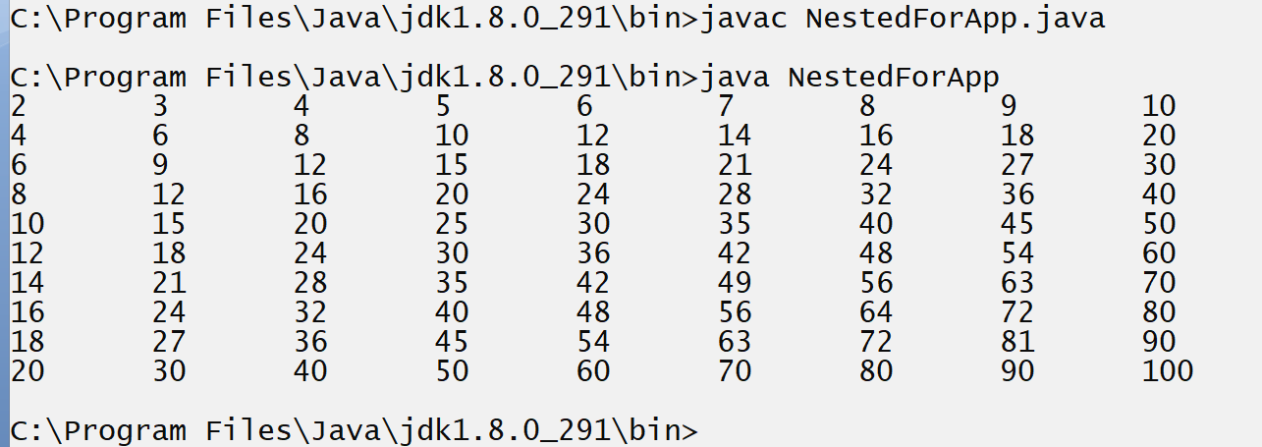

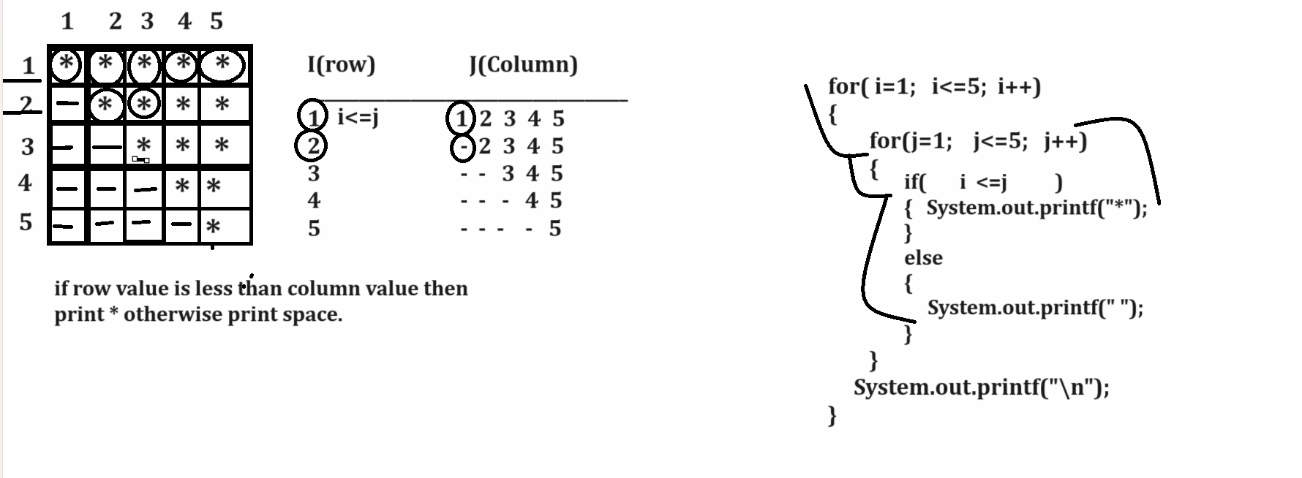
Example with source code
public class NestedForApp
{
public static void main(String x[])
{
int i,j;
for(i=1; i<=5;i++)
{
for(j=1; j<=5; j++)
{
if(i<=j)
{ System.out.printf("*");
}
else{
System.out.printf(" ");
}
}
System.out.printf("\n");
}
}
}
Output
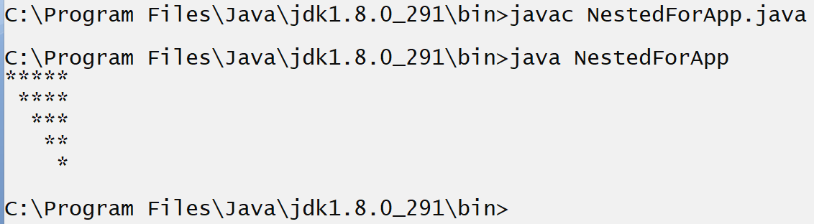
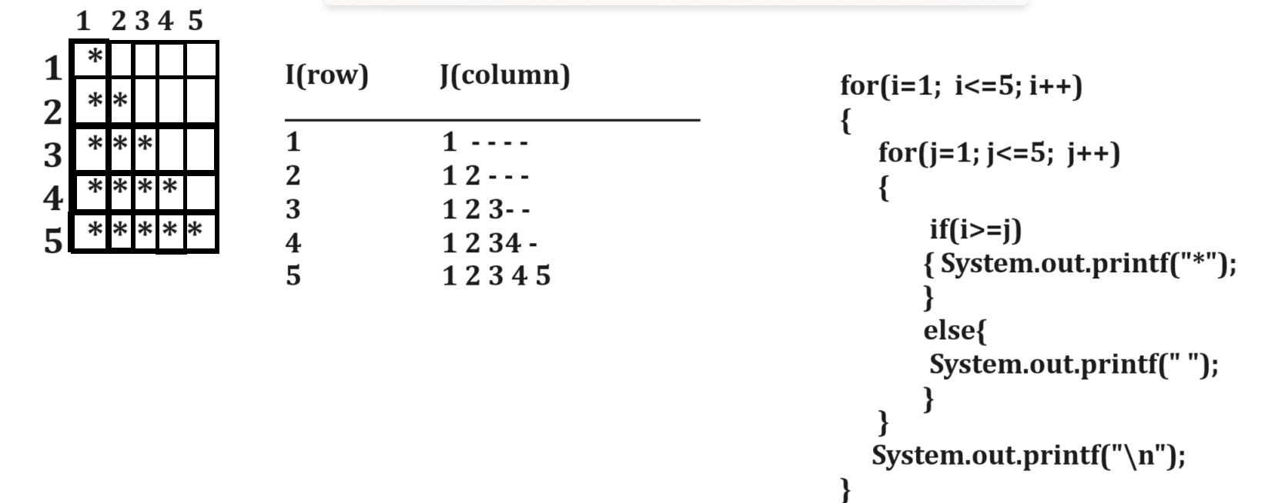
Example with source code
public class NestedForApp
{
public static void main(String x[])
{
int i,j;
for(i=1; i<=5;i++)
{
for(j=1; j<=5; j++)
{
if(i>=j)
{ System.out.printf("*");
}
else{
System.out.printf(" ");
}
}
System.out.printf("\n");
}
}
}
Output
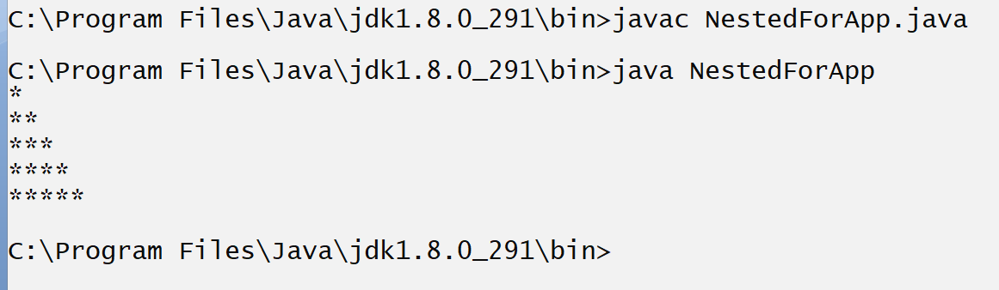
Example: WAP to print following patterns
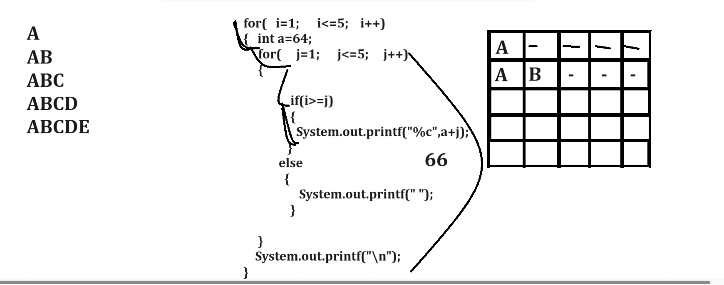

Example with source code
public class CharPatternApp
{
public static void main(String x[])
{
int i,j;
for(i=1;i<=5;i++)
{ int a=64;
for(j=1; j<=5; j++)
{
if(i>=j)
{
System.out.print("%c",a+j);
}
else{
System.out.printf(" ");
}
}
System.out.printf("\n");
}
}
}

Example: WAP to program print the following pattern.
public class CharPatternApp
{
public static void main(String x[])
{
int i,j;
for(i=1;i<=9;i++)
{
for(j=1; j<=5; j++)
{
String s=((i>=j && i<=5)||(j<=10-i&& i>=6))?"*":" ";
System.out.print(s);
}
System.out.printf("\n");
}
}
}

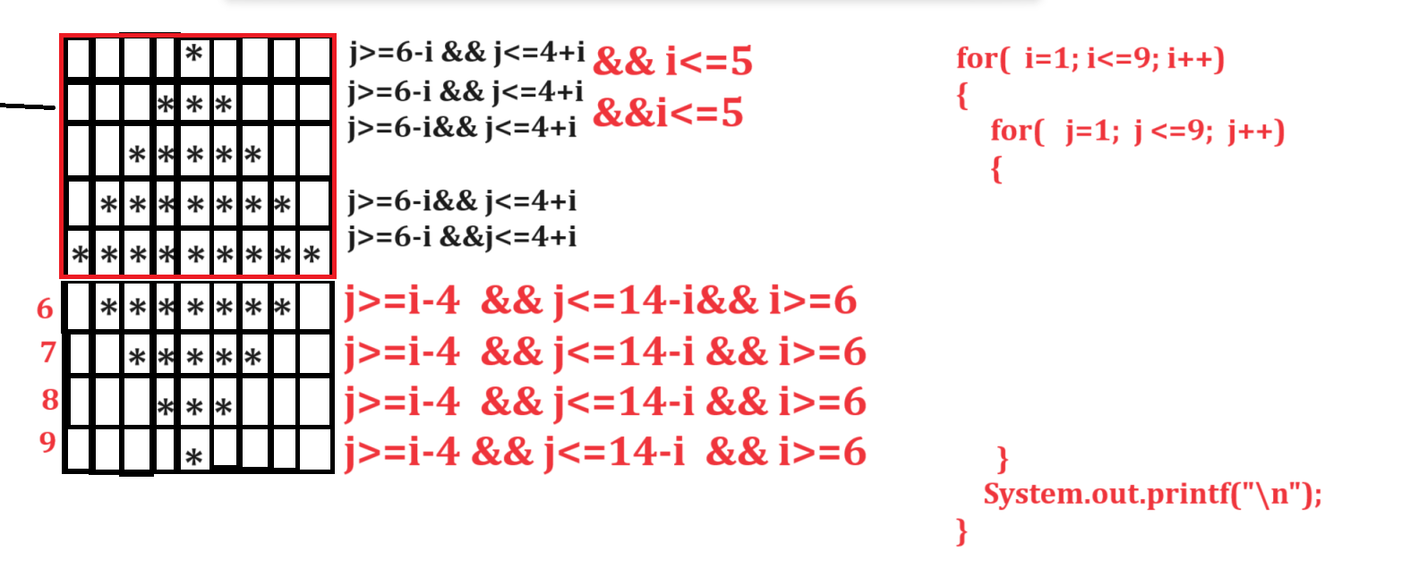
Example with source code
public class CharPatternApp
{
public static void main(String x[])
{
int i,j;
for(i=1;i<=9;i++)
{
for(j=1; j<=9; j++)
{
String s=((j>=6-i && j<=4+i && i<=5)||(j>=i-4 && j<=14-i && i>=6))?"*":" ";
System.out.println(s);
}
System.out.printf("\n");
}
}
}
Example: WAP to draw the following patterns?
______________________________________________________________________________
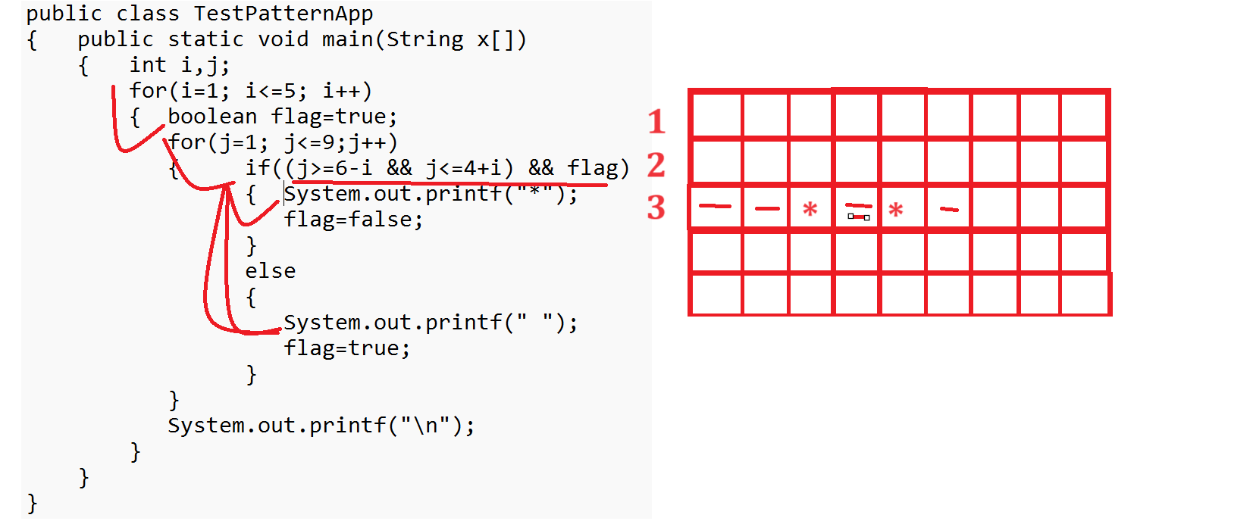

Example with source code
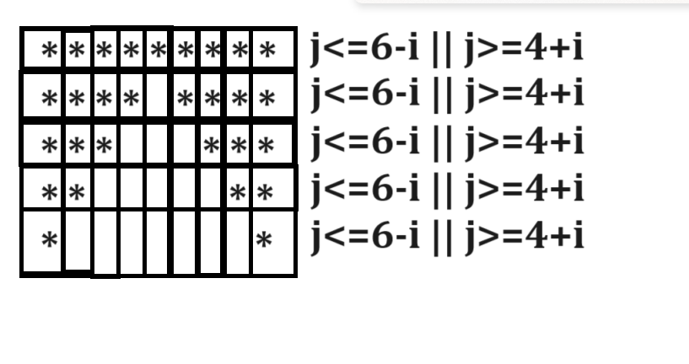
Source code
public class TestPatternApp
{ public static void main(String x[])
{ int i,j;
for(i=1; i<=5; i++)
{
for(j=1; j<=9;j++)
{ if((j<=6-i || j>=4+i))
{ System.out.printf("*");

}
else
{
System.out.printf(" ");
}
}
System.out.printf("\n");
}
}
}
Example: WAP to print the following patterns.

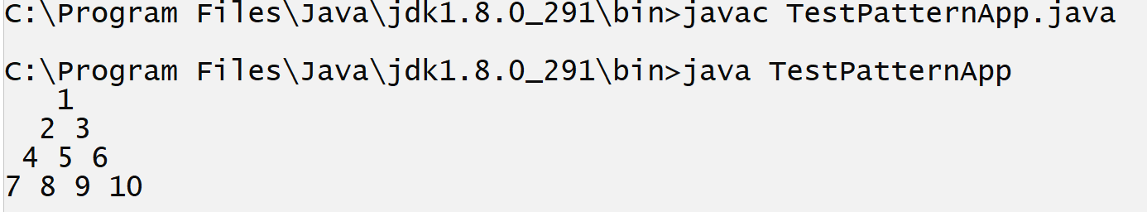

public class TestPatternApp
{ public static void main(String x[])
{ int i,j,k=0;
for(i=1; i<=4; i++)
{ boolean flag=true;
for(j=1; j<=7;j++)
{ if((j>=5-i && j<=3+i) &&flag)
{
System.out.printf("%d",++k);
flag=false;
}
else
{
System.out.printf(" ");
flag=true;
}
}
System.out.printf("\n");
}
}
}

Example with source code
public class ButterflyApp
{
public static void main(String x[])
{
int i,j;
for(i=1; i<=10; i++)
{
for(j=1; j<=10; j++)
{
if(((j<=i || j>=11-i) && i<=5)||((j<=11-i ||j>=i) && i>=6))
{
System.out.printf("*");
}

else{
System.out.printf(" ");
}

}
System.out.printf("\n");
}
}
}
Output
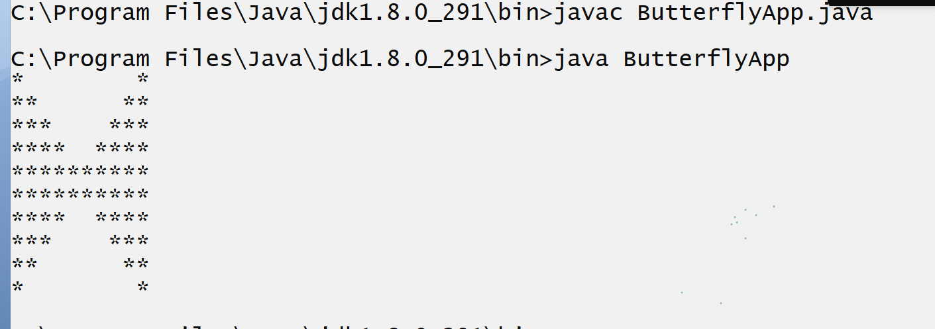

Example with source code
public class ButterflyApp
{
public static void main(String x[])
{
int i,j;
for(i=1; i<=10; i++)
{
for(j=1; j<=10; j++)
{
if(((j<=6-i || j>=5+i) &&i<=5) ||((j<=i-5 || j>=16-i) &&i>=6))
{ System.out.printf("*");
}
else
{ System.out.printf(" ");
}
}
System.out.printf("\n");
}
}
}
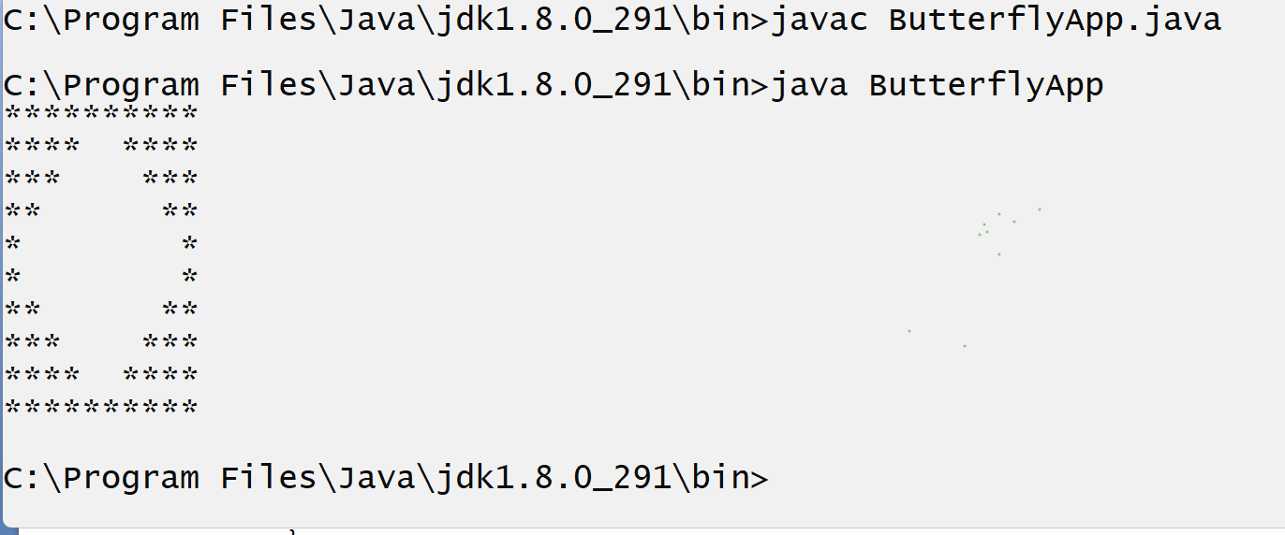

Example with source code
public class ButterflyApp
{
public static void main(String x[])
{
int i,j;
for(i=1; i<=7; i++)
{ int row=1;
for(j=1; j<=7; j++)
{
if(i>=j)
{ System.out.printf("%d ",row);
row=row*(i-j)/j;
}
else{
System.out.printf(" ");
}
}
System.out.printf("\n");
}
}
}
Output
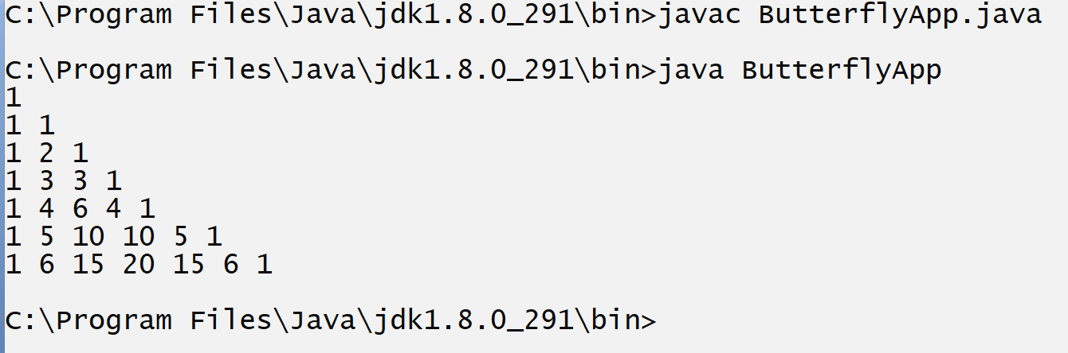
Example with source code
public class ButterflyApp
{ public static void main(String x[])
{ int i,j;
for(i=1; i<=5; i++)
{ int row=1;
for(j=1; j<=9; j++)
{
if(j>=6-i && j<=4+i)
{ System.out.printf("%d",row);
if(j<5)
{ ++row;
}
else{
--row;
}
}
else
{ System.out.printf(" ");
}
}
System.out.printf("\n");
}
}
}
Output
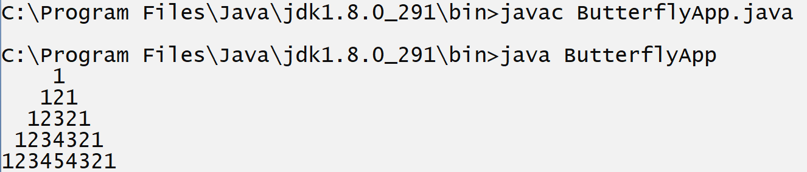

Do while loop
______________________________________________________________________________
Do while loop is exit control loop means first execute the loop and after that check condition means if your condition false first time your loop will be execute minimum single time.

Syntax:
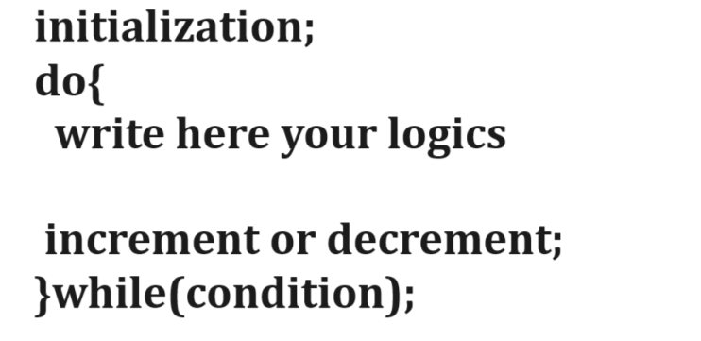

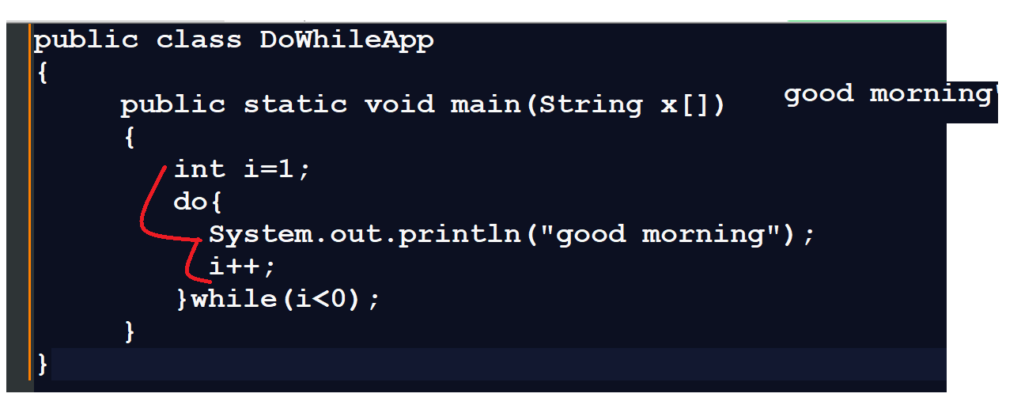
Example with source code
public class DoWhileApp
{ public static void main(String x[])
{ int i=1;
do{
System.out.println("good morning");
i++;
}while(i<0);
}
}
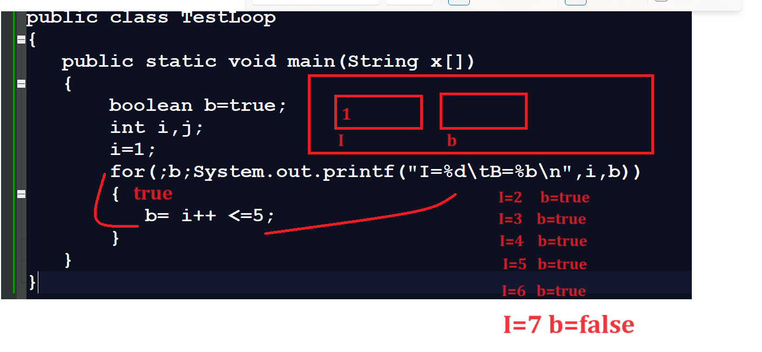
Example with source code
public class TestLoop
{ public static void main(String x[])throws Exception
{ byte b=1;
while(b<=127)
{ System.out.printf("%d\n",b);
b++;
Thread.sleep(100);
}
}
}

continue
______________________________________________________________________________
continue keyword is used for skip the some execution steps of loop called as continue keyword.

Example
public class TestLoop
{ public static void main(String x[])throws Exception
{
int i=0;
while(i<10)
{ i++;
if(i%2==0)
{ System.out.printf("I=%d\n",i);
continue;
}
System.out.printf("I = %d\n",i);
}
}
}

